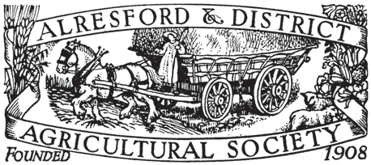

ALRESFORD AGRICULTURAL
SHOW 2023

SATURDAY 2 SEPTEMBER

PRESIDENT: MR DAVID REES

SCHEDULE

Cereals

At Tichborne Park, Alresford, Hampshire, SO24 0PN
(by kind permission of Tichborne Estate and the Grange Farm Partnership)
Cereals, Pulses, Oilseed and Hay Schedule

Chief Steward - James Atkinson
Judge – Mr Jonathan Arnold – Robin Appel Ltd.
Cereals Tent kindly sponsored by Frontier Agriculture Ltd.

Entry Fee: Free
Prize Money in each class 1st £10.00
Entries will be accepted on the day.
1kg of a named variety is required for all Cereal, Pulses and Oilseed Classes
Cereals

CLASS 500 Milling Wheat - Group 1 varieties.
Sponsored by Frontier Agriculture Ltd

CLASS 501 Milling Wheat - Group 2 varieties.
Sponsored by Frontier Agriculture Ltd

CLASS 502 Soft Milling Wheat - Group 3 varieties.

CLASS 503 Feeding Wheat - Group 4 varieties.
Sponsored by Frontier Agriculture Ltd

CLASS 504 Spring Malting Barley
Sponsored by Robin Appel Ltd

CLASS 505 Winter Malting Barley
Sponsored by Robin Appel LtD

CLASS 506 Feeding Barley

CLASS 507 Oats
Sponsored by Robin Appel Ltd
Pulses, Oilseeds & Hay

CLASS 508 Peas
Sponsored by Crop Management Services

CLASS 509 Beans
Sponsored by Crop Management Services

CLASS 510 Oilseed Rape
Sponsored by Crop Management Services

CLASS 511 Best Bale of Meadow Hay
Sponsored by Frontier Agriculture Ltd

CLASS 512 Best Bale of Seeds Hay
Sponsored by Frontier Agriculture Ltd

CLASS 513 Linseed
Sponsored by Robin Appel Ltd

The ADAS PCC will be awarded to the winner of the best three Cereal entries from different classes.

