The Alresford & District Agricultural Society

Alresford Agricultural Show

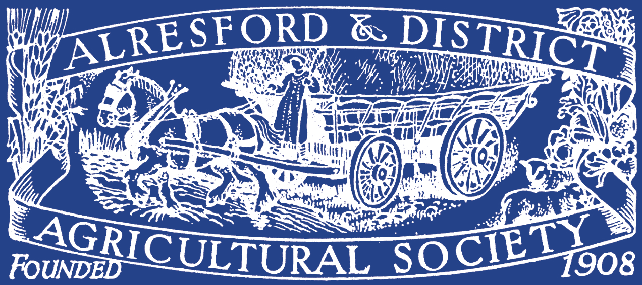

Invitation to AGM 2024

Wednesday 6 March, 7.30

At Alresford Golf Club

Alresford Show - Saturday 7 September 2024

Annual General Meeting 2024

NOTICE IS HEREBY GIVEN that the Annual General Meeting of the Alresford & District Agricultural Society will take place on Wednesday 6 March, 7.30
At Alresford Golf Club

AGENDA
1. Apologies for absence

2. To confirm the minutes of the Annual General Meeting of the Society held on 25 January 2023

3. To receive the Treasurer's report and, if approved, to adopt the Audited Statement of Accounts for the year ended 31 October 2023

4. To receive the Chairman's report on the activities of the Society during the year ended 31 October 2023

5. To receive a report from committees
(a) Horse & Pony
(b) Livestock
(c) Catering
(d) Sponsorship
(e) Showground
(f) Social Media & Marketing
(g) Discover Food & Farming

6. To elect for the ensuing year the following officers:
(a) President
(b) President-elect
(c) Honorary Vet. Surgeons
(d) Honorary Solicitor
(e) Honorary Accountants

7. To elect for the ensuing year the following Trustees:
(a) Mr M Cheyney
(b) Mrs H Jones
(c) Mrs A Raimes
(d) Mr P Sharpe

8. To elect for the ensuing year the following sub-committees:
(a) Horse & Pony
(b) Livestock
(c) Catering
(d) Sponsorship
(e) Showground
(f) Social Media & Marketing
(g) Pre-Show
(h) Discover Food & Farming

9. (a) Nominations for Vice President:
Mr David Rees
(b) Nominations for Hon. Vice President:
Mr Chris Lillywhite
Mr Chris Monnington
Miss Mary Rook
Mrs Sally Bowden

10. To confirm:
(a) The date of the Show for 2024:
7 September 2024 at Tichborne Park, (by kind permission of the Tichborne Estate & Grange Farm Partnership)
(b) Closing date for entries:
Livestock: Wednesday 31 July 2024
Horse & Pony: Wednesday 28 August 2024
11. To consider any motion or other business of which prior notice has been given to the Secretary at least one week before the date of the Annual General Meeting.
Proposed Show Committees 2024

Trustees are appointed every three years. All were appointed in 2016 and thereafter on the following rotation. The Trustees shall appoint a Trustee to act as Chair and to chair their meetings and may at any time revoke such appointment. The Trustees shall appoint a Trustee to act as Vice-chair and may at any time revoke such appointment. The Board of Trustees shall at all times include the Treasurer.

Elected Members
+ Mr C Corbett ^ Mr J Allison * Mr M Cheyney
+ Lt Col (retd) H Mallory ^ Mr R Goodall * Mrs H Jones
^ Miss R Corbett * Mrs A Raimes
^ Mr S Cross * Mr P Sharpe
^ Mr E Pettit-Mills
^ Mr B Robinson

+ Retire AGM 2025 ^ Retire AGM 2026 * Retire AGM 2027

The board of Trustees may delegate any of its power or functions to a sub-committee including one or more Trustee.

Sub-Committees

Showground Livestock Sponsorship
Mr C Lillywhite Mr B Robinson (Trustee) Mr S Cross (Trustee)
Mr J Allison (Trustee) Mrs S Bowden Mr B Cross
Mr M Cheyney (Trustee) Mr M Bailey Mrs A Trenchard
Mr C Corbett (Trustee) Mrs J Barker
Mrs H Flindt Mr C Cheyney
Mr R Goodall (Trustee) Mr M Cheyney (Trustee) Social Media & Marketing
Mr D King Mr J Garrett Miss B Corbett (Trustee)
Mr P Mills Miss H Jackson Ms N Webster
Mr E Pettit-Mills (Trustee) Mrs K Miles (Secretary)
Ms L Priestley-Cooper (Secretary) Mr T Walters Discover Food & Farming
Mrs A Raimes (Trustee) Mr E Pettit-Mills (Trustee)
Mr B Robinson (Trustee) Mr J Allison (Trustee)

Horse & Pony Pre-Show Catering
Mrs A Raimes (Trustee) Mrs K Roadnight (Poultry) Mrs H Jones (Trustee)
Mrs S Axel-Berg Mr W Tufnell Mrs N Cartwright
Mrs V Cobden (Secretary) Mr N Webb Mrs V Pettit-Mills
Mrs E Mallory Mrs I Williams (WI) Miss M Rook
President, President Elect Mrs A Trenchard
Plus all other committee Members

Board of Trustees
Sponsorship

Horse
& Pony
Livestock

Catering

Social Media
& Marketing
Showground

Pre-Show

Membership Information

Become A Member of The Show Society

And receive the following benefits:
- Entrance to the Showground
- Admission to the Members' Club
- Exclusive ringside seating on the Members Club Lawn
- Opportunity to reserve a table in the restaurant for morning coffee, lunch or afternoon tea
- Reduced entry fees in equine, cattle, sheep and goat classes
- Opportunity to purchase ringside parking for the main ring (not available to non-members)
- Right to attend and vote at the Society's Annual General Meeting

Membership

- LIFE
Two badges:- a Life Member badge and a Guest badge for the duration of life of the member

- ANNUAL MEMBERSHIP
Two badges;- a Member badge and a Guest badge

- ADDITIONAL GUEST BADGE(S)
Members are able to purchase additional badges for family and friends

- YOUNG PERSON MEMBERSHIP (30 and under)
One Member badge

- CHILDREN'S MEMBERSHIP
Members' children under the age of 16 can accompany their parents into the Member's Enclosure without a Guest badge

Method of Payment

- STANDING ORDER
Subscriptions are paid automatically each year in January; no need to write and post cheques. New Standing Orders can be processed throughout the year however subscriptions must be paid by 1 April each year to qualify for reduced entry fees. Most importantly you remain in control and can cancel the instruction whenever you wish.

- BY CHEQUE
Cheques payable in January each year and payable to Alresford & District Agricultural Society Ltd. (ADAS Ltd). New Members can pay by cheque throughout the year but subscriptions must be paid by 1 April each year to qualify for reduced entry fees.

- BY CREDIT/DEBIT CARD
Ring the Show Office, 01962 738748, or complete the payment details on the application form. New Members can pay by cheque throughout the year but subscriptions must be paid by 1 April each year to qualify for reduced entry fees.

Membership Application Form
Title: | Forename(s): | Surname:
Address:
Postcode:
Telephone:
Email Address:
Signature:

Package Type: |  |  |  |  |  | Price | Total
Life Member |  |  |  |  |  | £1000
Annual Member |  |  |  |  |  | £45**
Additional Guest Badge(s) |  |  |  |  |  | £25
Annual Young Person Membership (30 & under, please state DOB) |  |  |  |  |  | £16**
** If paid before 1st April. £10 joining fee applicable after 1st April.
Payment Method:

Surname:
Cheques to be made payable to: Alresford & District Agricultural Society Ltd
If you wish to pay your membership by Standing Order please contact the show office for a form If you wish to pay by Credit/Debit Card please fill in the following details:
Debit/Credit Card Type |  |  |  | Card Number
Start Date |  |  | Expiry Date |  | 3 Digit Security Code (on reverse)
Signature
Alresford & District Agricultural Society Registered Charity 298980
The Society is a charity that exists to improve agriculture for the public benefit by the improvement of livestock and the demonstration, exhibition and showing of livestock, machinery, crafts, products, methods and processes connected with the agriculture and agricultural education. Memorandum of Articles of Association of Alresford & District Agricultural Society Ltd. Can be viewed on application to the Secretary.

